
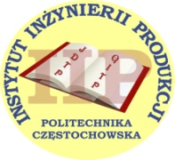

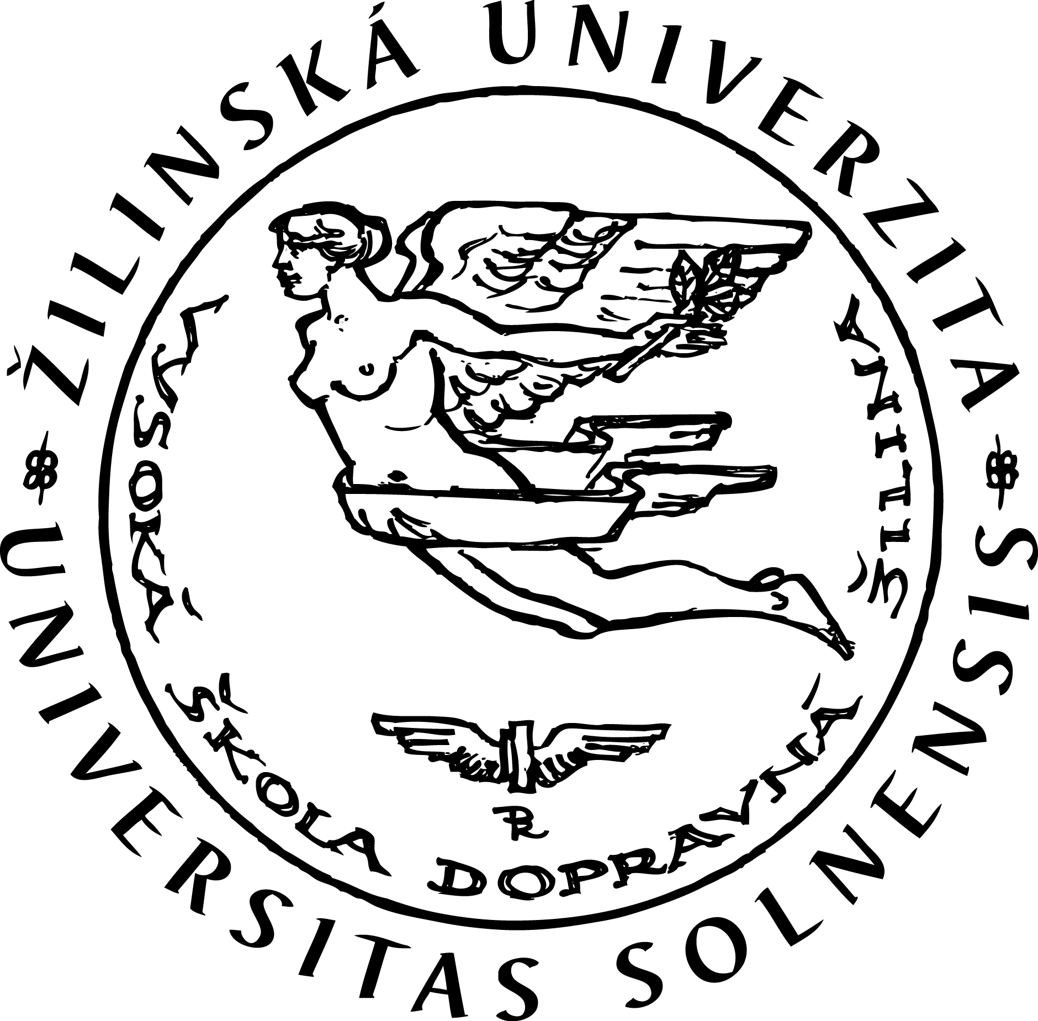


12th International Scientific Conference

Human potential development

27–28 May, 2015

Klaipėda University, Klaipėda, Lithuania



Conference is organized under the auspices of

Prof. Dr. Inga Žalenienė Assoc. Prof. Dr. Rita Vaičekauskaitė
Vice-Rector for Research Vice-Rector for Research
and International Relations of Klaipėda University
of Mykolas Romeris University Lithuania
Lithuania

and

International Academic Network HPD CEEUS
(Human Potential Development in Central and Eastern European Union States)

A goal of the Conference

The conference builds on its eleven-year tradition and continues not only in tradition but also an established quality. The goal of the 12th International Scientific Conference is of international scientific conference is knowledge exchange in the area of intentional human potential development and confrontation of the newest theoretical assumptions and actual conditions of the practice, focused on the need to change approaches to the forming, motivation and development of value-creating power of the organization – employees and managers.

Orientation of the Conference
- general issues of the human potential utilization and development (strategic management, human potential, social responsibility of business, ethics in the human potential development, higher education management, organizational culture, life-long learning and career, employer branding, work performance management, balance of the work and non-working life, flexible organization and flexible employment, personnel marketing, HR audit, HR controlling, modern forms of communication, the current ergonomics and environmental situation in organizations, safety at work);
- new challenges in the development of human potential and human resources management (confrontation of human potential and human capital, creating added value through people, the possibility of human potential measurement and appraisal, investment in human potential or capital, leadership, competence management, motivation of human potential, social media and information-communication technology in the human potential development, human potential and human resources in an era of recovering from global recession and social crisis);
- innovative models and practical approaches in area of human potential/human resource management and creativeness development (transfer of innovative models of human potential/resource management, culture of creativeness in the organization, wide approaches to talent management and creativeness development, age management, knowledge management, diversity management, value management, strategic workforce planning in regions, competencies of managers and employees in public administration, innovation in human potential development strategies, social innovations in human potential development and regional development).

Important information:
- In order to maintain the required quality of the forthcoming Proceedings, all papers will be reviewed by two unbiased reviewers. Proceedings will have own ISBN.
- Selected papers, written in the desired quality, recommended extent, and written in English, will be published in these two International Scientific Journals:
- Human Resources Management and Ergonomics (journal is featured in the citation database EBSCOhost ™ and Cabell’s Directories) – if authors are interested in this option, paper should be prepared in accordance with the journal requirements (http://frcatel.fri.uniza.sk/hrme/).
- Regional Formation and Development Studies (journal is featured in the EBSCO) – in this case, paper should be prepared in accordance with the journal requirements (http://www.ku.lt/smf/mokslas/moksliniai-zurnalai-scientific-journals/regionu).

Such papers will only be published in the journal and will not be included in the conference Proceedings.
- The conference is organized under the Scientific Project VEGA no. 1/0890/14 Stochastic Modeling of Decision-making Processes in Motivating Human Potential.

Scientific guarantee:

Assoc. Prof. Martina BLAŠKOVÁ, PhD. Prof. Dr. Rimantas STAŠYS

University of Žilina, Slovak Republic Klaipėda University, Klaipėda, Lithuania

Scientific committee of the Conference:
Prof. Ing. Josef KOUBEK, CSc.  Prague, Czech Republic  Prof. Dr. Peter Van Krieken  Hague University and AUC, Netherlands  Prof. Dr. José Luis Vázquez BURGUETE, PhD.  University of Leon, Spain  Prof. Dr.sc. dr.h.c. Vlado GOGLIA  University of Zagreb, Croatia  Prof. Eduard ISKHAKOV, MD.  Ufa Law Institute, Russia  Prof. Vladimiras GRAŽULIS, DrSc.  Mykolas Romeris University, Lithuania  Prof. Habil. Dr. Rūta ADAMONIENĖ  Mykolas Romeris University, Lithuania  Multi Prof. Dr. hab. Stanisław BORKOWSKI  University of Technology in Czestochowa, Poland  Prof. Milota VETRÁKOVÁ, PhD.  University of Matej Bel, Slovak Republic  Prof. Dr. Mircea COSMA  Sibiu University, Romania  Prof. Pavel TOMŠÍK, CSc.  Mendel University in Brno, Czech Republic  Prof. h.c. Dr. Václav LIŠKA, Dr.h.c.  Technical University in Prague, Czech Republic  Prof. Habil. Dr. Marta Juchnowicz  Warsaw School of Economics, Poland  Prof. Dr. Irena BakanauskienĖ  Vytautas Magnus University, Kaunas, Lithuania | Prof. Habil. Dr. Stasys VAITEKŪNAS  Klaipėda University, Lithuania  Prof. Habil. Dr. Julius RAMANAUSKAS  Klaipėda University, Lithuania  Prof. Dr. Diana ŠAPARNIENĖ  Sauliai University, Lithuania  Prof. Dr. Vilma ATKOČIŪNIENĖ  Aleksandras Stulginskis University, Lithuania  Assoc. Prof. Miloš HITKA, PhD.  Technical University in Zvolen, Slovak Republic  Assoc. Prof. Miriam JANKALOVÁ, PhD.  University of Žilina, Slovak Republic  Karin Köcher, PhD.  GETS – Berlin/Leipzig, Germany  Dr. Ewa MATUSKA, PhD.  Higher Hanseatic School of Management, Poland  Irena FIGURSKA, PhD.  Pomeranian Academy in Slupsk, Poland  Joanna ROSAK-SZYROCKA, PhD.  University of Technology in Czestochowa, Poland  Aneta Sokół, PhD.  University of Szczecin, Poland  Dr. Rudolf Blaško, PhD.  University of Žilina, Slovak Republic  Radoslav JANKAL, PhD.  University of Žilina, Slovak Republic

Editorial committee of the Conference:
Assoc. prof. Dr. Martina BLAŠKOVÁ, PhD.  University of Žilina, Slovak Republic  Prof. Dr. Vladimiras GRAŽULIS, DrSc.  Mykolas Romeris University, Lithuania | Prof. Dr. Ligita ŠIMANSKIENĖ  Klaipėda University, Lithuania  Dr. Rudolf Blaško, PhD.  University of Žilina, Slovak Republic

Organizational committee of the Conference:
Chair: Assoc. prof. Dr. Rūta DaČiulytĖ, Mykolas Romeris University, Lithuania
Members: Radoslav JANKAL, PhD., University of Žilina, Slovak Republic
Jurgita Paužolienė, student PhD, Klaipėda University, Lithuania

Important deadlines:
Registration | 15th March 2015 | Sending completed application form to contact e-mail, including the designation of food and accommodation booking
Paper sending | 31th March 2015 | Sending of paper to contact e-mail
Decision of scientific committee of paper acceptation | 15th April 2015 | Sending information of paper acceptation and assigned ID of the participant
Payment | 30th April 2015 | Payment of conference fee
Conference session | 27–28 May 2015 | Conference session

Conference languages: English, Russian

Publication languages: English, Polish, Slovak, Russian, Czech, German

Conference fee:
90 € | Participation in the conference (includes paper processing, review, print conference proceedings, organizational costs, refreshments during the conference)
60 € | Fee for members of the international academic network HPD CEEUS and members of the Conference Scientific Committee (includes all elements of conference participating)
60 € | Fee for PhD students (includes all elements of participating in the conference)
60 € | Passive participation = papers publication in proceedings (including paper processing, review, printing and distribution of conference proceedings)

Organizational guidelines:
The 12th annual international conference of Human Potential Development will take place on 27–28 May 2015 in the Klaipėda University conference room.

The conference is to be lodged by 30 April 2015 in accordance with dispositions in the attached application form and by payment of the conference fee (including VAT) to the account:
Account No IBAN: LT857300010002492590 Reg. No.: 111951726
VAT. Reg. No.: LT119517219 SWEDBANK AB
Bank code: 73000 SWIFT: HABALT22
Address: Ateities str. 20, LT-08303, Vilnius, LITHUANIA, Mykolas Romeris University
Purpose of payment: 12th International Scientific Conference “Human Potential Development”

Into the message, please include: name of participant and assigned identifier (ID).

Food and accommodation during the conference should be ordered in the application. Accommodation should be paid on the reception of hotel.

Organizers:
Mykolas Romeris University, Ateities str. 20, LT-08303 Vilnius, Lithuania, ruta.daciulyte@gmail.com; phone +370 612 63421
Klaipėda University, Herkaus Manto str. 84, LT-92294 Klaipėda, Lithuania, klaipeda.university@ku.lt; phone +370 46 39 89 08

Contact e-mail: hpd@frcatel.fri.uniza.sk

Web information: http://frcatel.fri.uniza.sk/hrme/ConfHPM/index.html

PUBLICATION RULES
Please, kheep the following directions related to paper writing:
- Papers can be writen in English, German, Russian, Polish, Slovak and Czech.
- Paper intended into the conference proceedings (including tables, pictures and schemes) should be worked out minimally on 6 pages of A4 format. In a case of your interest to publish paper in journal HRM+E, the recommended extent of paper is 12 – 15 pages A4, lines 1, with the using min. 30 references; paper has to be in English.
- For the text editing, please, use MS Word, Times New Roman CE, line spacing 1, 2.5 cm margins.
- Form of paper content:
- paper title (in language of paper as well as in English, 14 pt, bold, centered)
- author’s name (12 pt, centered)
- abstract (in English, max. 15 lines, 10 pt, justified)
- key words (in English, max. 10 words, 10 pt, justified)
- text of paper (headlines – 12 pt, bold, align left; text – 12 pt, justified)
- author’s address with titles can be given on the end of paper.
- Citations of other authors should be marked in the text of paper (in brackets, including name of used author, year of publishing and number of used pages).
- Check of bibliography (used literature) should be given at the end of paper, including ISBN (books) or ISSN (journals) as follows:
Milkovich, G. T. & Boudreau, J. W. (1988). Personnel/Human Resource Management. A diagnostic Approach. Fifth edition. Homewood, Illinois: Irwin. 872 p. ISBN 0-256-15963-2.
Millet, K., Lamey, L. & Van den Bergh, B. (2012). Avoiding Negative vs, Achieving Positive Outcomes in Hard and Prosperous Economic Times. Organizational Behavior and Human Decision Processes, 118(2), 179–188. ISSN 0749-5978.
Unger, S. (2006). Special features of Swedish corporate governance. The Swedish Corporate
Governance Board. (online) (cit. 2015-03-05) Available at: http://www.scania.com/images/special_features_or_swedish_corporate_governance_av_sven_unger_tcm40-170350.pdf.
- Send the papers by e-mail to the contact address.

